

**High Level Design & Low Level Design**

**Document Control :**

|  |  |  |  |  |  |  |  |  |
| --- | --- | --- | --- | --- | --- | --- | --- | --- |
| **Project Revision History** | | | | | | | | |
|  |  |  | |  |  |  |  |  |
| **Date** | **Version** | **Author** | **Brief Description of Changes** | | | | **Approver Signature** | |
| 26.09.2022 | 1.0 | Group 5 |  | | | |  | |
|  |  |  |  | | | |  | |
|  |  |  |  | | | |  | |

**Index**

|  |  |
| --- | --- |
| Title | Page No |
| 1. Introduction | 1 |
| * 1. Project Purpose | 1 |
| * 1. Project Scope | 1 |
| * 1. Intended Use | 1 |
| * 1. Project Scope | 1 |
| * 1. Glossary and reference | 1 |
| * 1. Overview | 2 |
| 1. Overall Descriptions | 2 |
| * 1. User Needs | 2 |
| * + 1. Beneficiary | 2 |
| * + 1. Government Personnel | 2 |
| * 1. Assumptions and Dependencies | 2 |
| 1. Detailed Features and Requirements | 3 |
| * 1. Functional Requirements | 3 |
| * 1. Non-Functional Requirements | 5 |
| * + 1. Usability | 5 |
| * + 1. Performance | 5 |
| * + 1. Security | 6 |
| * + 1. Supportability | 6 |
| * + 1. Design Constraints | 6 |
| * + 1. Reliability & Availability | 6 |
| * 1. External Interface Requirements | 6 |
| * + 1. Tools Used | 6 |
| * + 1. Software Interface | 7 |
| * + 1. Hardware Interface | 7 |
| Data Flow Diagrams | 8 |

1. **Introduction**

The introduction of the High Level Design (HLD) and Low Level Design (LLD) provides an overview of the entire document with purpose, intended audience, scope and key objectives. The purpose of this High Level Design (HLD) Document is to add the necessary detail to the **Model City Vaccination Drive Application’s** description to represent a suitable model for coding. This document is also intended to help detect contradictions prior to coding, and can be used as a reference manual for how the modules interact at a high level. This application will manage vaccine registrations and the data involved in the vaccination drive.

* 1. **Project Purpose**

This online application would track all the new users, schedule vaccination slots for registered users and update all the data related to registered users.Secondly, the application also allows only the authorized city government employees to update the registered user’s database, track vaccine units in various centre and view specific required information related to vaccination drive.

* 1. **Intended Audience**

This document is intended to be read by clients, designers , program and solution teams.

The intended audience for this application is the citizen that want to get vaccinated whereas the application is to be supervised by government personnel.

* 1. **Project Scope**

The Model City Vaccination drive is specifically developed for the vaccination of the beneficiaries. This application allows the beneficiaries to register for the vaccination drive at any of the 3 centres available and also book their slots. Secondly, the application allows only authorised personnel to delete the fully vaccinated beneficiaries record. Also, he can create a vaccine file containing all the 3 centre codes and number of units of vaccine available across the centres just before the vaccination begins. He can also get the list of all the beneficiaries who got vaccinated today.

* 1. **Key Project Objectives**
* Allow Beneficiaries to apply for vaccination drive.
* Create account for new beneficiaries.
* Beneficiaries can access the application using aadhar number.
* Maintain the data related to beneficiary and vaccination.
* Schedule slot timing for registered beneficiaries.
* Government personnel are given the role of admin to access the specific functions.
* Only Admin can update or modify the databases present in this application.

1. **Design Overview**

Model City Vaccination Drive comprises of following modules:

* Menu

|  |  |
| --- | --- |
| Name of the Module | Main Menu |
| Handled by | Aboli Pawar |
| Description | This module contains the general user login |

|  |  |
| --- | --- |
| Name of the Module | Beneficiary Login |
| Handled by | Aboli Pawar |
| Description | This module contains menu restricted for beneficiaries only. |

|  |  |
| --- | --- |
| Name of the Module | Check Password |
| Handled by | Anuja Nikam |
| Description | This module verifies the password that are restricted for admin role only. |

* **User Corner**

|  |  |
| --- | --- |
| Name of the Module | New User Menu |
| Handled by | Aboli Pawar |
| Description | Consists menu for users that are new to the application. |

|  |  |
| --- | --- |
| Name of the Module | Create Account |
| Handled by | Nitika Mhatre |
| Description | This module lets user create account by entering valid details. |

|  |  |
| --- | --- |
| Name of the Module | View User Details |
| Handled by | Aboli Pawar |
| Description | This module will display the details entered by the user while creating the account. |

|  |  |
| --- | --- |
| Name of the Module | Registered User Menu |
| Handled by | Vaastav Talwar |
| Description | Consists menu for users that are already existing in database of the application. |

|  |  |
| --- | --- |
| Name of the Module | Select Centres & Book Slot |
| Handled by | Anuja Nikam |
| Description | Consists of centre names from which user can select centre upon vaccine availability. Lets user book a slot according to specific timing . |

|  |  |
| --- | --- |
| Name of the Module | Get Vaccination |
| Handled by | Vaastav Talwar |
| Description | This module lets user complete the vaccination process by verifying a token. |

* **Admin Corner**

|  |  |
| --- | --- |
| Name of the Module | Admin Menu |
| Handled by | Vaastav Talwar |
| Description | This module displays all the functions available to admin role. |

|  |  |
| --- | --- |
| Name of the Module | Display Beneficiary Records |
| Handled by | Nitika Mhatre |
| Description | This module shows all the beneficiary records. |

|  |  |
| --- | --- |
| Name of the Module | Edit & Display Vaccine Units |
| Handled by | Nitika Mhatre |
| Description | This module lets admin edit and display the vaccine units available in centres. |

|  |  |
| --- | --- |
| Name of the Module | Display & Delete Fully Vaccinated |
| Handled by | Vaastav Talwar ,Nitika Mhatre |
| Description | This module shows the fully vaccinated records and delete them in the database. |

|  |  |
| --- | --- |
| Name of the Module | Display Not Vaccinated & Today Vaccinated |
| Handled by | Anuja Nikam |
| Description | This module shows the beneficiary records. |

1. **Detailed System Design**
   1. **Data Flow Diagram**
      1. Level 0

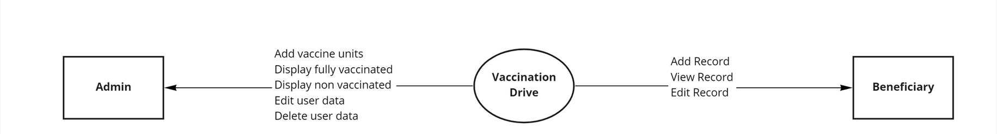

* + 1. Level 1

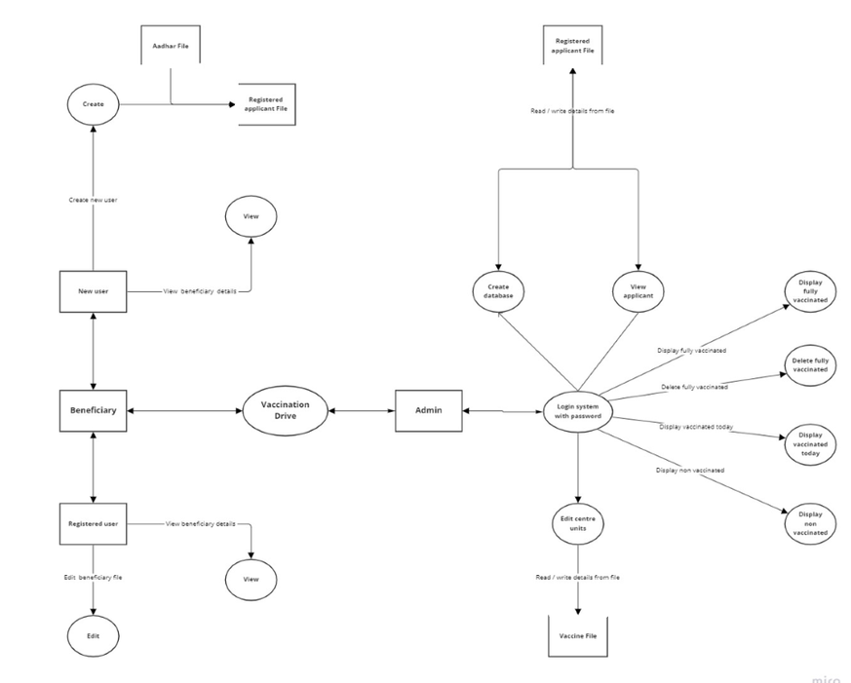

* 1. **Flowcharts**
     1. **Beneficiary Flowchart**

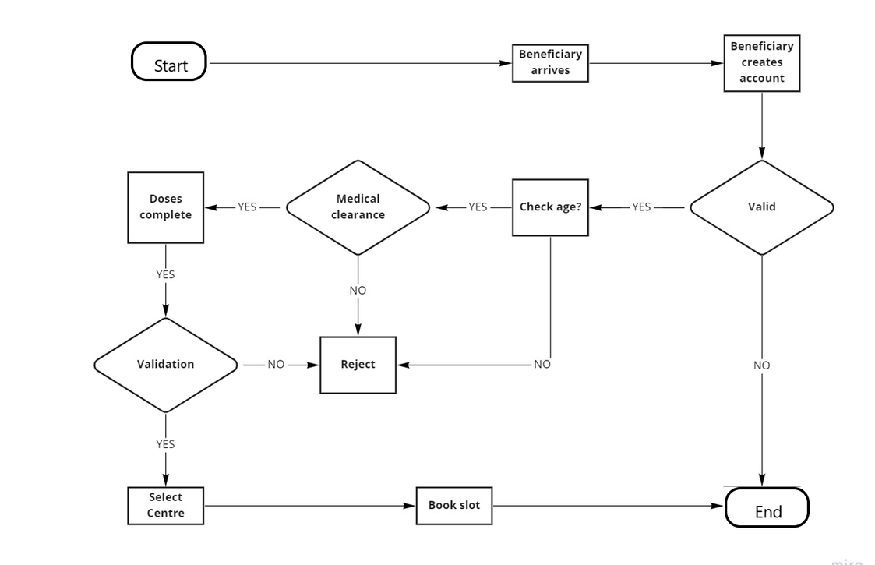

* + 1. **Admin Flowchart**

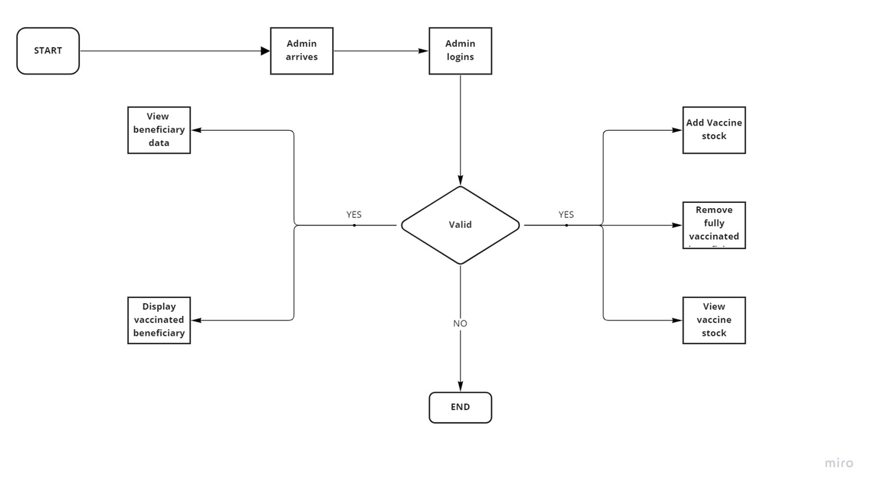

* + 1. **Combined Flowchart**

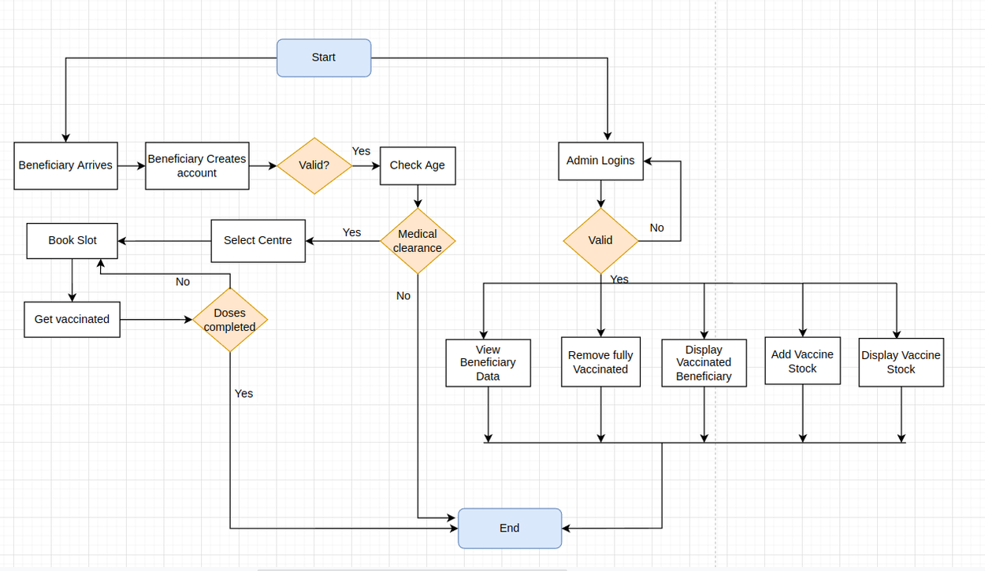

* 1. **ER Diagram**

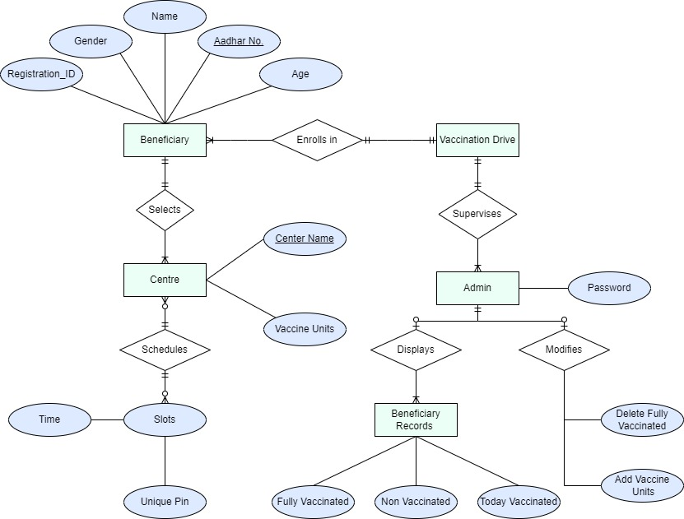

* 1. **Sequence Diagram**

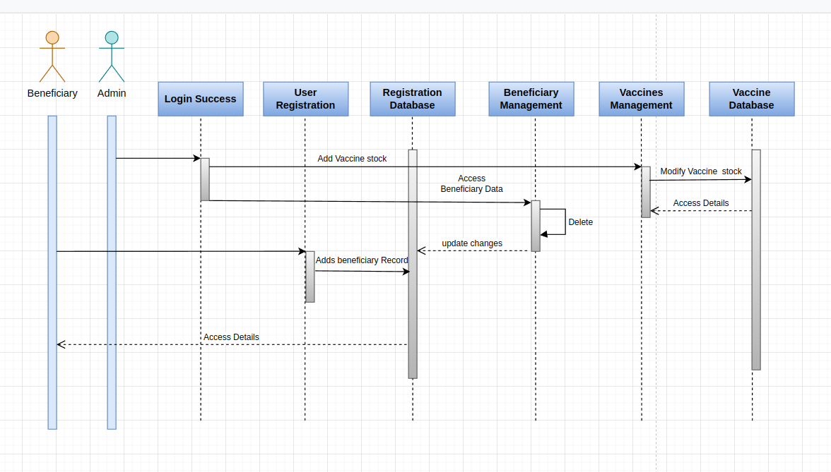

* 1. **Usecase Diagram**

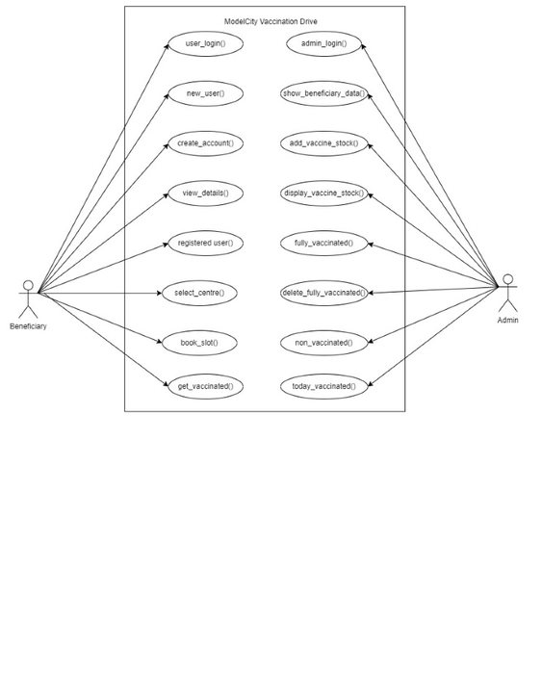

* 1. **Class Diagram**

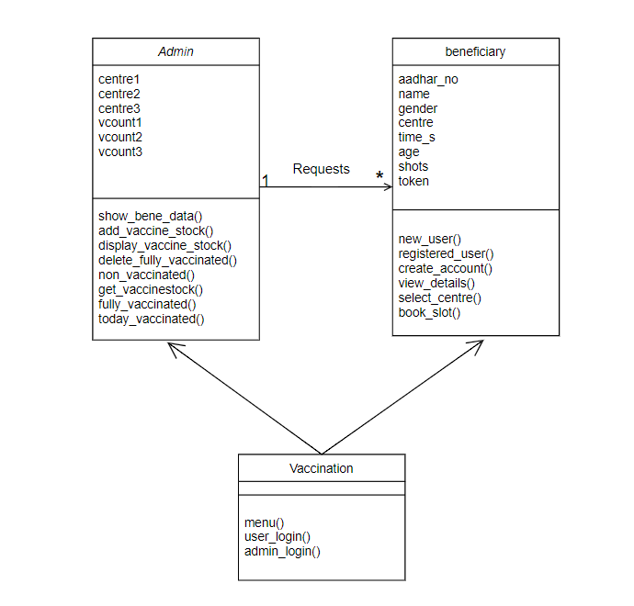

* 1. **Pseudocode**
* Aadhar_len()

Aadhar length = INPUT : “ Enter aadhar number:”

IF aadhar length is equal to 6

PRINT “Valid Length”

ELSE

PRINT “Invalid Length”

ENDIF

* Select_centre():

Aadhar number = INPUT: “Enter your aadhar number:”

IF aadhar number is valid

THEN

INPUT: “Please select your centre to book a slot:”

IF center is equal to 1

PRINT “Hawkins”

ELSE IF center is equal to 2

PRINT “Riverdale”

ELSE IF center is equal to 3

PRINT “ Central Perk”

ELSE

PRINT “Invalid Centre”

ENDIF

ELSE “Invalid aadhar number”

ENDIF

* book_slot():

Aadhar number= INPUT: “Enter your aadhar number:”

IF aadhar number is valid

THEN

INPUT: ”Book your slot:”

IF centre is equal to 1

THEN

PRINT “1. MORNING”

INPUT: “Confirm your time between 10 to 12”

IF time slot is between 10 to 12

PRINT “Valid time slot”

ELSE

PRINT ”Invalid time slot”

ELSEIF centre is equal to 2

THEN

PRINT “2. EVENING”

INPUT: “Confirm your time between 1 to 4”

IF time slot is between 1 to 4

PRINT “Valid time slot”

ELSE

PRINT ”Invalid time slot”

* 1. **Validations**
* A unique 6-digits aadhar has to be entered by the beneficiary while creating an account. Also, an existing account holder cannot create an account as the aadhar number already exists in Registered_applicant_file.
* This application allows only beneficiaries above 18 years to apply for vaccination drive. Beneficiaries above age 35 need medical clearance in order to apply for vaccination.
* Name
* Gender
* passwd
* The number of vaccination shots for each beneficiary is restricted to 3.
* The vaccine file as well as the registered_applicant_file can be only modified by the user having the role of Admin.

1. **Detailed Features and Requirements**
   1. **Functional Requirements**
      1. menu():The user will be encountered with two options after starting the application: 1.Beneficiary Login 2. Admin Login. Beneficiaries are the ones who want to apply for vaccination drive whereas the admin login is for government personnel's who would supervise the vaccination drive.
      2. user_login():

There would be two choices for beneficiary login: 1.New 2.Registered. The registered beneficiaries can access the application by entering the allocated register id. Whereas the new beneficiaries have to enter the required details and is redirected to Registered choice.

* + 1. new_user():

After choosing the new option in the previous login, user will be given two options: 1. Create Account 2.View Details.

* + 1. create_account():

Details such as name, aadhar number, gender and age are to be entered for creating a new account.  
These details are first crosschecked with Aadhar File and only then they will be stored in Registered Applicant file.

* + 1. view_details():

Details of the created account are viewed

* + 1. registered_user():

Menu for registered beneficiary will be displayed.

* + 1. select_centre():

Vaccination centres are selected by beneficiaries based on location and availability.

* + 1. book_slot():

Slots are selected according to beneficiary's' convenience.

* + 1. get_vaccinated():

The beneficiary has to verify the token provided while filling the slot, only after this the vaccination is said to be successful. After completion of this stage, the count of the vaccination unit is decremented for that particular centre in the vaccination file.

* + 1. checkpassword():

A government personnel can login by entering the specified password so as to access all the functions related to the vaccination application. Only after the password is matched, the screen is directed to Admin menu.

* + 1. admin_login():

Menu for admin role will be displayed.

* + 1. show_bene_data():

Data of all the beneficiary records is displayed.

* + 1. add_vaccine_stock():

The user would be able to edit the of number of vaccine units allocated to each centre. These details are than updated in Vaccine file.

* + 1. display_vaccine_stock():

Displays the details of number of vaccine units in each allocated centres. These details are fetched from Vaccine file.

* + 1. fully_vaccinated():

Displays the list of beneficiary that have vaccine count equal to 3. These details are fetched from Registered Applicant file.

* + 1. delete_fully_vaccinated():

The user would be able to delete the record of the beneficiary that have reached the vaccine count to 3. These details are than updated in Registered Applicant file.

* + 1. non_vaccinated():

Displays the list of beneficiaries that have vaccine count equal to 0. These details are fetched from Registered Applicant file.

* + 1. today_vaccinated():

Displays the list of beneficiary that have been vaccinated today. These details are fetched from Registered Applicant file.

1. **Tools Report**
   1. **Cpp Check:**

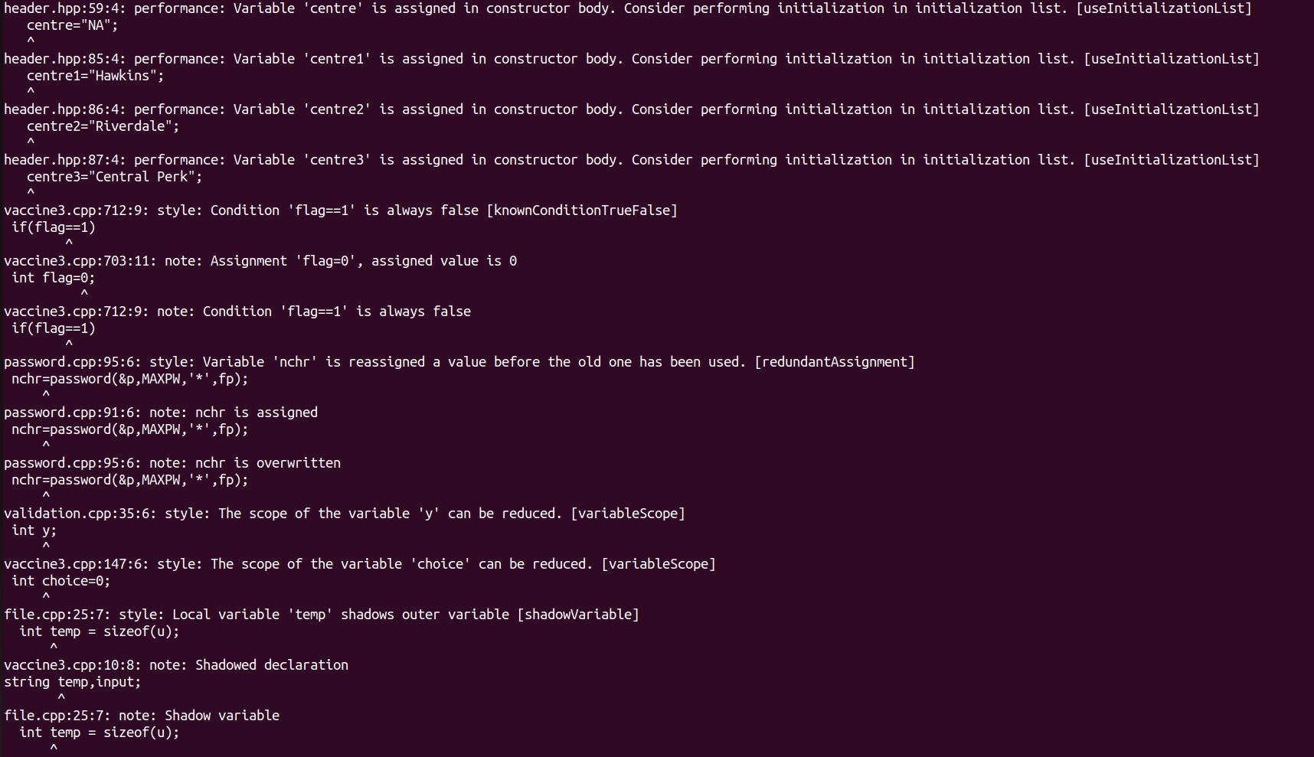

* 1. **Gcov:**

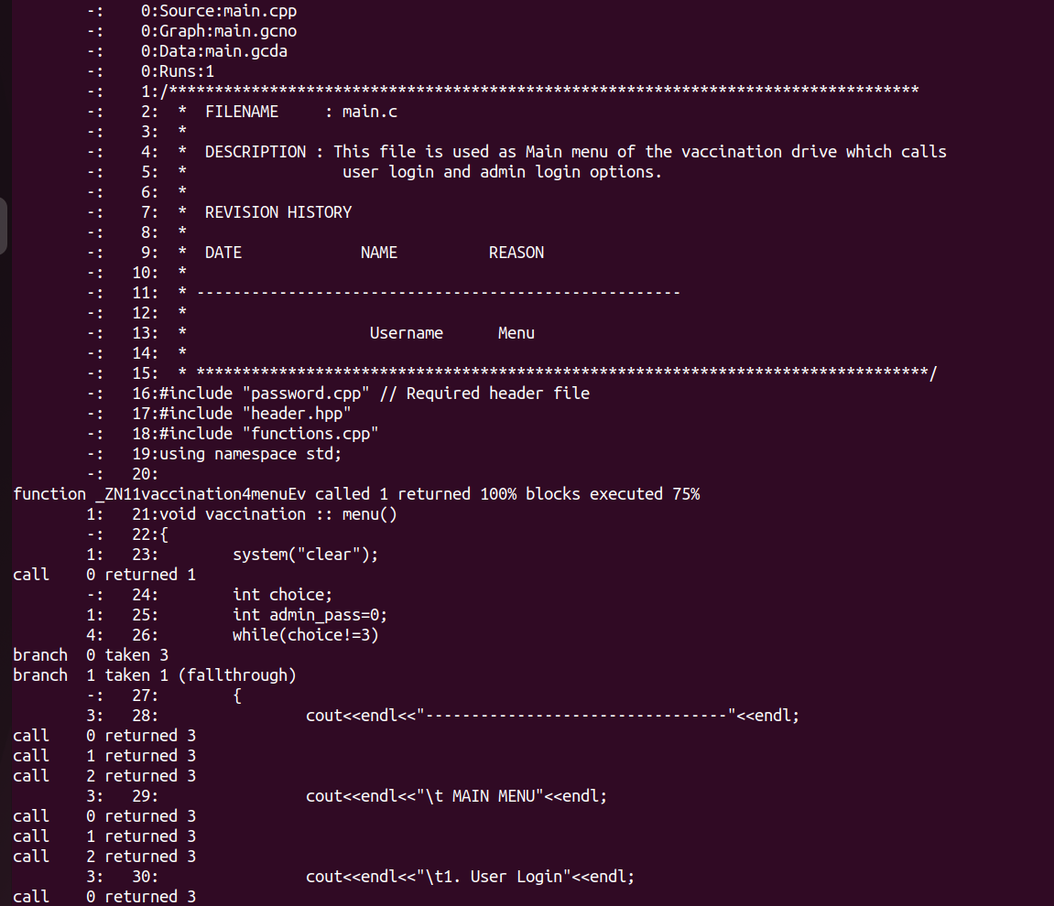

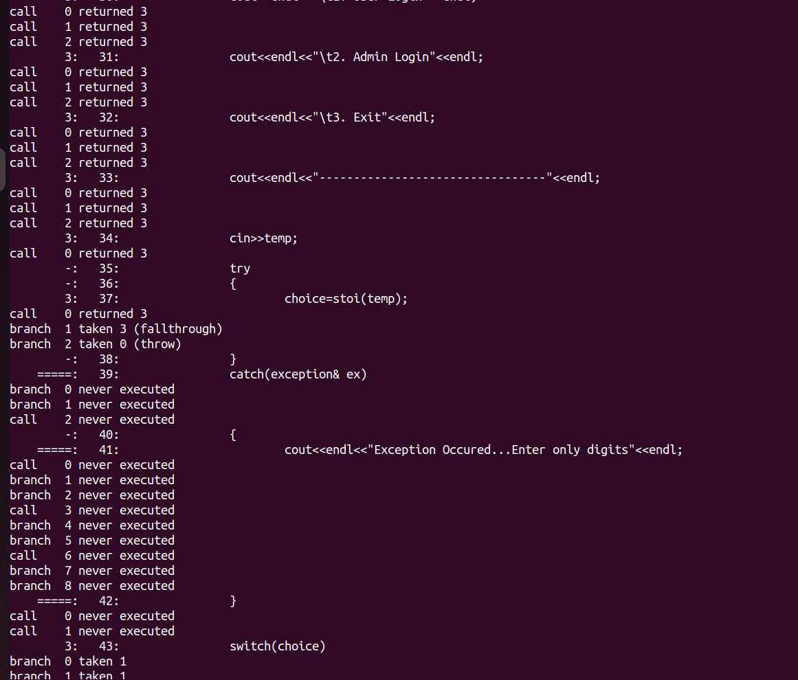

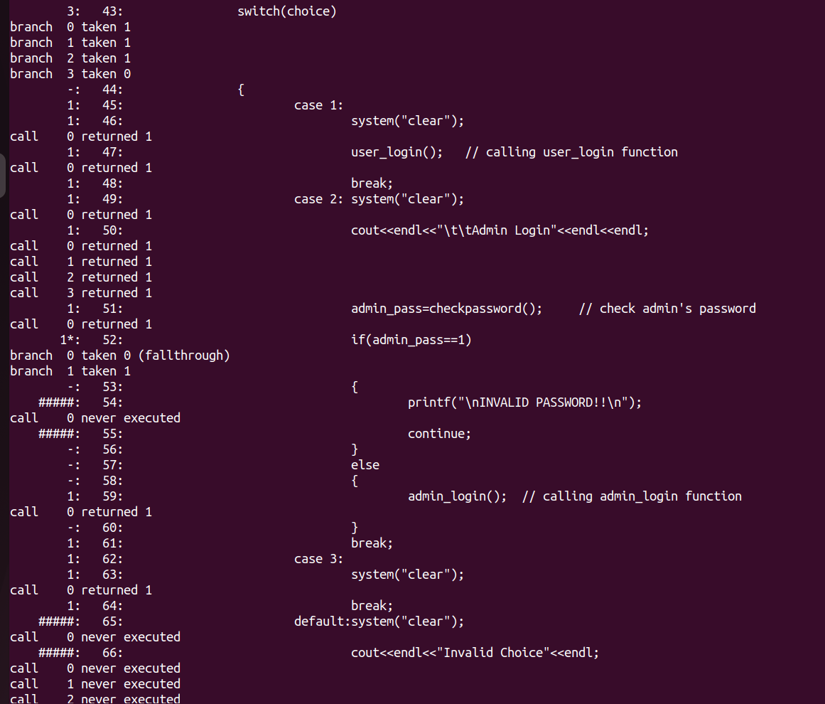

* 1. **Gprof**

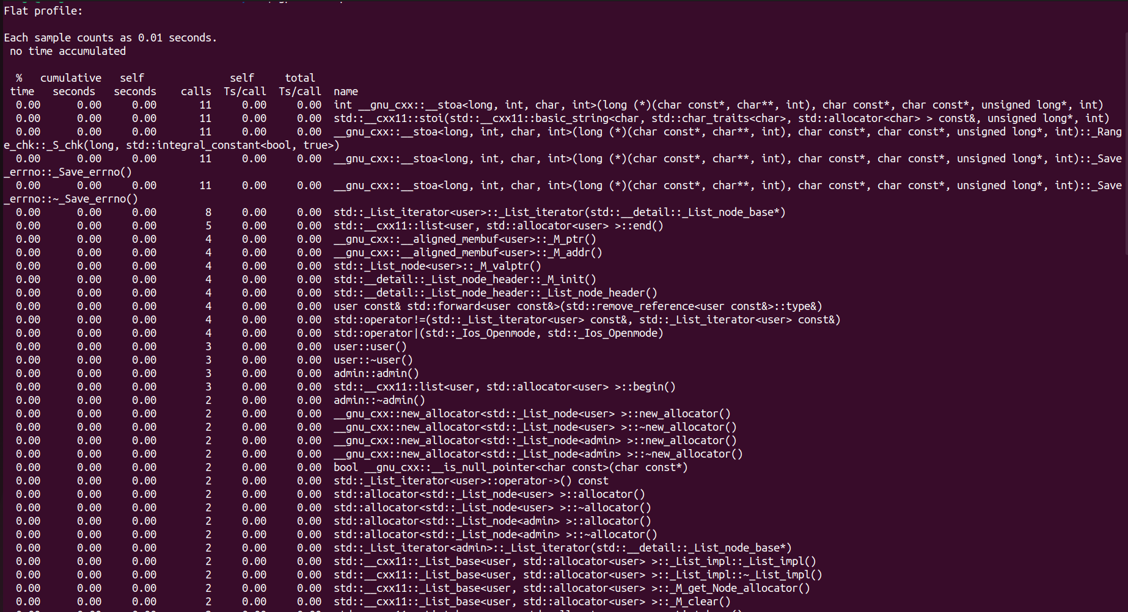

* 1. **Valgrind**

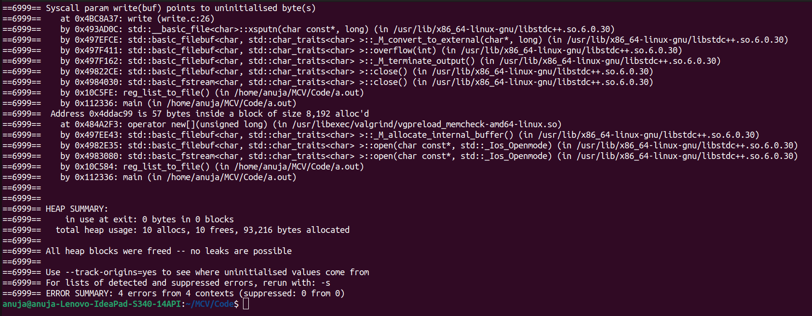

1. **Testing**
   1. **Unit Testing**

**1.Create Account**

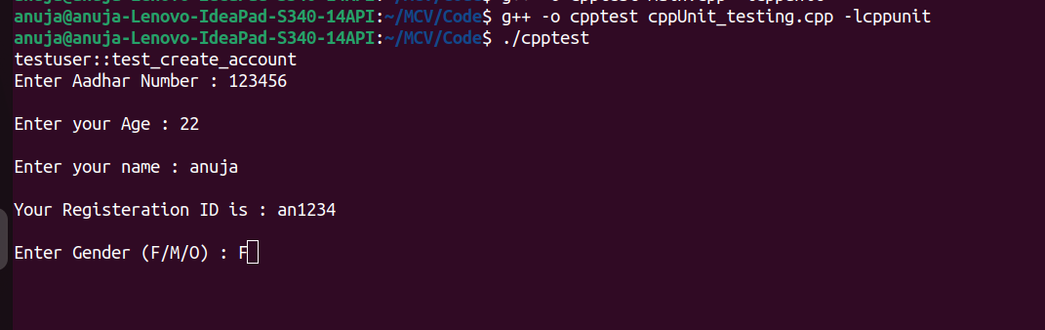

**2.View Details**

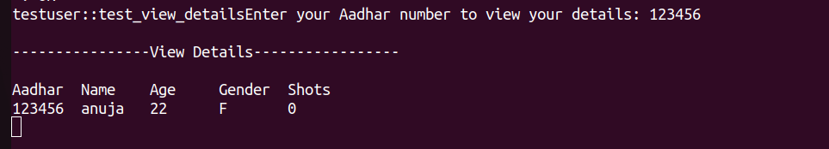

**3.Select Centre**

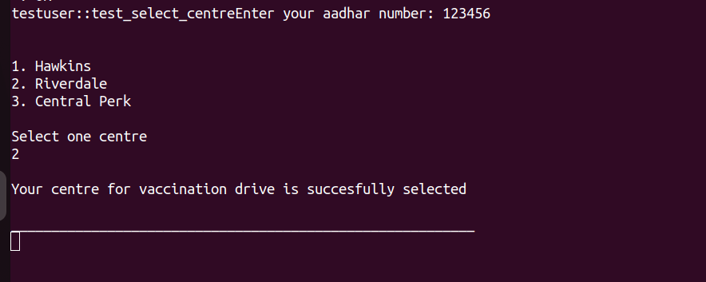

**4.Book Slot**

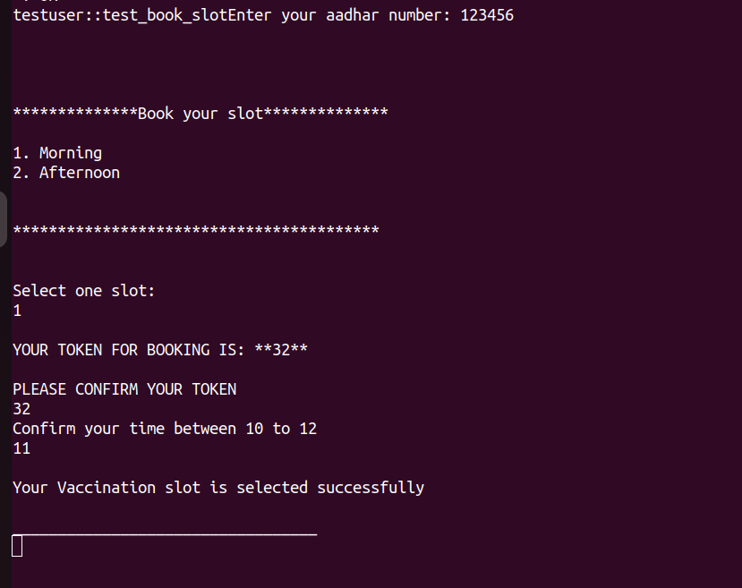

**5.Get Vaccinated**

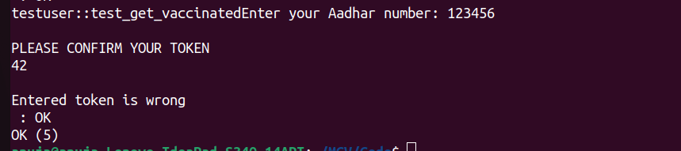

* 1. **Integration Testing**

**IT_CASE 1:  For creating account**

**IT_CASE 2 : View Details**

**IT_CASE 3 : Select Centre**

**IT_CASE 4 : Book Vaccine Slot**

**IT_CASE 5 : Get Vaccinated**

**IT_CASE 6: Show Beneficiary**

**IT_CASE 7: Add Vaccine Stock**

**IT_CASE 8 : Display Vaccine Stock**

**IT_CASE 9 : Delete Fully Vaccinated Beneficiaries**

**IT_CASE 10: Display non Vaccinated Beneficiaries**

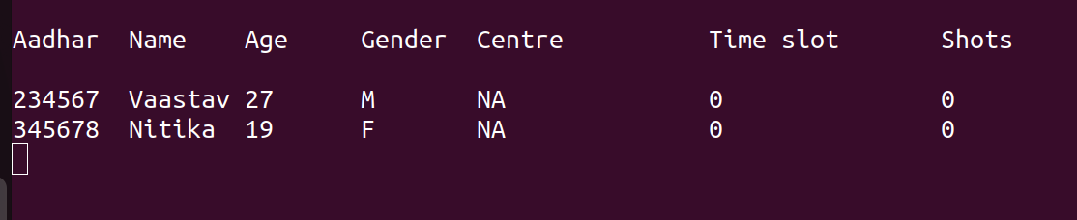

**IT_CASE 11 : Display Fully Vaccinated Beneficiaries**

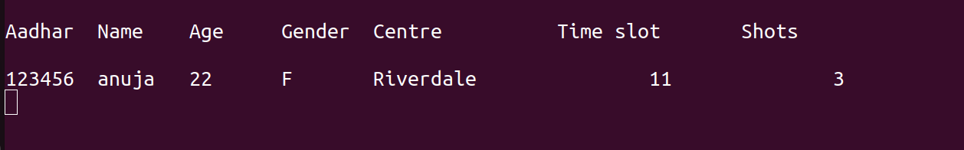

**IT_CASE 12 : Display Today Vaccinated Beneficiaries**

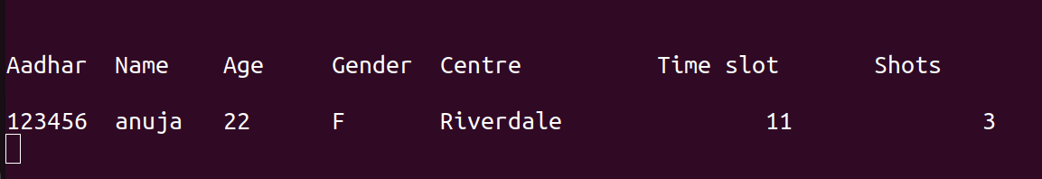

1. **Requirement Traceability Matrix**



1. **Reference**